**From:** Art King, SpiderCloud

Microsoft Research Indoor Localization Competition Winners (ranked by precision and including links to academic papers):

<http://research.microsoft.com/en-us/events/ipsn2014indoorlocalizatinocompetition>/

I don’t think we have a formal paper that effectively defines all the methods available to make a venue achieve “location awareness”

Regardless of the type of RF spectrum that is used, there are also two independent ways the systems operate.

1. Infrastructure Mode – where the infrastructure tracks device locations by their unique identity either over time or on-demand. This location information is exposed via a programmatic API to business application middleware or consumer applications. The main dependency is that the device being located has the correct RF technology on-board to be found.
2. Independent Mode – where the device locates itself inside infrastructure and has access to a positioning database that allows it to pinpoint itself by some method when outdoor systems are not visible to the device. This assumes that there is software either installed in the operating system of the mobile of that comes with an App that can do the triangulation work. It also depends on hardware and operating system capabilities to make the services available. For privacy reasons, some API’s are restricted by either regulation or the supplier.

The known RF location methods:

* A-GPS – Assisted GPS and may not work in many places due to inability to see satellites.
* Wi-Fi – Infrastructure RF Triangulation dependent on mobile radio status (on/off) and AP coverage density, AP placement, and AP location “stability”.
* Licensed Spectrum – RF Triangulation dependent on mobile radio band and RN coverage density, RN placement, and RN location “stability”.
  + Note that the industry thinks the licensed spectrum can be regulatory requirement for First Responders and others can leverage.
* BLE – Low Energy Bluetooth that is not really “location based services” but a “proximity detection” method. To take it from “proximity” to “location” implies a dense and structured installation of the BLE sensors (like Apple iBeacon).
* Proprietary solutions – Many exist, may lose out to [Apple, Google, Wi-Fi, and Licensed spectrum] systems due to sheer market size of those 4.

Pros/Cons:

* There is no one method or vendor that is common to all. Achieving good location coverage requires some understanding of customer devices and behaviours to make a choice correct for the customers to be served.
* Infrastructure Mode locating methods are much more robust due to lack of dependencies on “all the planets to be in alignment” for Independent Mode (App installed, OS services support App, RF technology enabled, all software release levels correct).
* Sometimes the things that exist are not used due to lack of knowledge or personal preference. While Wi-Fi and Bluetooth may ship in many newer devices, for both technologies, there are human limits. For instance, mobile operators report globally that 30% of their devices that have Wi-Fi on-board have NEVER had it enabled. There are no stats for Bluetooth, but it may even be a higher number as the use case for Bluetooth (hands free) is smaller than the use case for Wi-Fi (self-offload from licensed spectrum while stationary).

In summary, there are no clear winners but there are practical decisions that can be made depending on what the business goals are.

**From:** Sen, Souvik, HP (SmartShopper)

1. Positioning vs. Proximity: Beaconing technology does not provide position as in <x,y> coordinate. It only provides proximity as in near which beacon are you. The proximity data is also crude -- unlike CUPID that can give you distance, beacon technologies only give report high, medium, low proximity.

2. Accuracy: In general beaconing technology has poor accuracy than any Wi-Fi-based positioning system. This is because beaconing technology does not employ multilateration which employs multiple Wi-Fi APs intelligently to reduce the positioning error.

3. Applicability: Although beacons are cheap, to cover an entire store a large number of them needs to be deployed and managed. This may add to OPX.

**From:** Nuckley, Matthew, HP (Keats Platform)

I think one obvious con of Bluetooth beacons, or NFC tags, or some of the others, is that the data to serve some of the enhancements would need to come from a 2nd data network source…  e.g. a Bluetooth sipping approach would trigger data to be consumed from 3G or Wi-Fi anyway

I’m aware of several location technologies…

* Location Services from the Network (VF has a MMS based service that locates within 300m, using the same multilateration system as the Keats Platform should get around 500m accuracy too)
* Location services from handset or OS provider (e.g. Google providing a basic location based on IP address or Wi-Fi details)
* NFC Tags or QR codes registered to a location (Could include RFID, but most phones don’t have a reader at the moment)
* Aurasma auras associated with landmarks or unique pictures
* Active RFID beacons (E.g. ones from Zebra)
* Bluetooth Beacons… (described in the paper Lee sent)
* Zigbee services (or other radio network systems, might gain interest as home automation and Smart Meters become more common in a consumer setting)
* Wi-Fi methods (I’m aware that there are 4 or 5 different ways of getting location from Wi-Fi, most get to a 3-5m accuracy.  CUPID to one side)
* GPS /GLONASS or similar, obviously
* I think there are some more exotic systems
  + based on facial recognition (I heard of a system that recognises people in Pubs and sends an alert to bouncers)
  + 3D sensors
  + Biometrics
  + Specific light or sound beacons, etc…

+a paper from Forrester (Mentioned as supplemental reading in the paper that Lee sent…)  <http://www.forrester.com/You+Are+Here+Location+Analytics+And+The+Rebirth+Of+Customer+Experience/fulltext/-/E-RES103021>

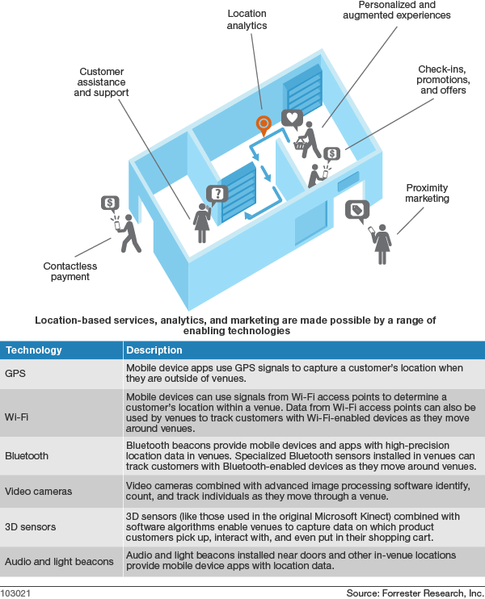

**From:** Odini, Marie-Paule, HP (CMS WW)

 (Comparison with other methods on page 7 and 8)

Additional links supplied…

<http://www.scoop.it/t/indoor-localisation>

[http://es.slideshare.net/fitc_slideshare/indoor-positioning-techniques-in-2014-where-are-they-now#](http://es.slideshare.net/fitc_slideshare/indoor-positioning-techniques-in-2014-where-are-they-now)